**Jamaican Beef Patties**

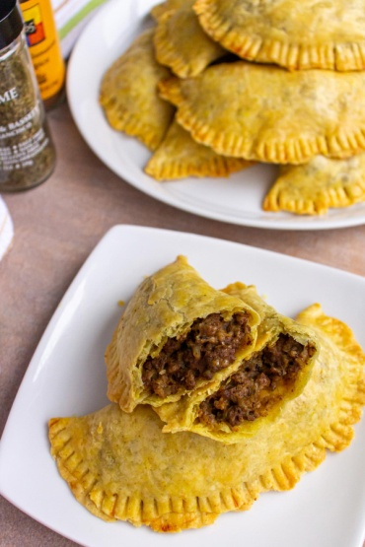

**INGREDIENTS**

**PASTRY INGREDIENTS**

250 grams (2 cups) Plain Flour (All Purpose)

115 grams (½ cup) Unsalted Butter

1 teaspoon Turmeric

1 teaspoon Garam Masala substitute with any blend of curry powder

1 teaspoon Salt

120 ml (½ cup) Ice Cold Water

**BEEF FILLING**

1 tablespoon Vegetable oil

1 Onion Finely Chopped

1 Red Pepper (bell pepper) Finely Chopped

3 Spring Onions (scallions) Finely Chopped

500 grams (1.2lb) Beef mince

1 teaspoon Gia Garlic Puree 2 cloves of garlic

1 teaspoon Gia Chilli Puree 2 medium chillies (Jalepeno/Serrano) or 1 hot chilli (Habanero/Scotch Bonnet)

2 teaspoon Garam Masala substitute with any blend of curry powder

1 teaspoon Paprika

1 teaspoon Turmeric

1 teaspoon Salt

1 teaspoon Fresh Thyme substitute ½ teaspoon dried thyme

190 ml Stock we used 1 beef stock cube

Grated Cheese (optional) to add to filling

**GLAZE**

1 Egg

2 tablespoon Water

**METHOD**

**PASTRY**

1. Put all Pastry ingredients (except the water) in a food processor and tap the pulse button to slowly incorporate the butter into the flour.
2. If doing by hand rub butter into flour until it represents fine breadcrumbs, try to work as quick as possible to avoid butter melting
3. 250 grams (2 cups) Plain Flour (All Purpose),115 grams (½ cup) Unsalted Butter,1 teaspoon Turmeric,1 teaspoon Salt,1 teaspoon Garam Masala
4. Plain flour,cubes of butter, garam masala and turmeric in a food mixer
5. Add ice-cold water bit by bit and knead with hands into the dough until it forms a playdoh like texture. (you may need a little less/more water than stated above)
6. Try not to handle to much.
7. 120 ml (½ cup) Ice Cold Water
8. Ice cold water being added to the pastry mix in the food mixer
9. Place pastry covered in the fridge whilst you create the beef filling.
10. Ball of pastry in a sandwich beg to be placed in the fridge to chill

**BEEF MINCE PATTY FILLING**

1. Heat oil in pan and add onions and red peppers sautee for 5 minutes until soft, add spring onions.
2. 1 tablespoon Vegetable oil,1 Onion,1 Red Pepper (bell pepper),3 Spring Onions (scallions)
3. Add mince, garlic, chilli, paprika, garam masala, turmeric and salt. Stir through until mince has browned
4. 1 teaspoon Salt,500 grams (1.2lb) Beef mince,1 teaspoon Gia Garlic Puree,1 teaspoon Gia Chilli Puree,2 teaspoon Garam Masala,1 teaspoon Paprika,1 teaspoon Turmeric,1 teaspoon Salt
5. Finally add dried/fresh thyme and stock.
6. Place lid on and leave to simmer for 15 minutes whilst you cut out pastry.
7. 190 ml Stock,1 teaspoon Fresh Thyme

**CREATE PATTIES**

1. Preheat oven to 180°C fan/ 200°C/ 400°F / Gas Mark 6.
2. Remove pastry from fridge, flour surface and roll out very thin.
3. Use a saucer/small plate (about 17cm diameter) to cut around the pastry.
4. Re-roll remaining pastry until all used up, you should have 5-6 circles.
5. Or you could use smaller plates and create smaller patties?!
6. Cutting out circle shapes in our pastry with a black plate to make our Jamaican beef patties
7. Now put rolled out circles on to there own bit of parchment paper and add 2-3 tablespoon of beef mixture in the middle
8. Grated Cheese (optional)
9. Use finger to dap the outer circle with water
10. Coating the edge of the pastry with water with our fingers
11. Fold pastry over the mince and use a fork to crimp the edges together
12. Whisk egg with water and brush on pastry to glaze.
13. For a flat pastry fork a hole in the top.
14. For a puffed-up pastry (as I like them) leave out the hole!
15. 1 Egg,2 tablespoon Water
16. Place all completed patties on to a tray (or two) and cook in the 180°C fan/ 200°C/ 400°F / Gas Mark 6 oven for 20-25 minutes.

**WHAT IS A JAMAICAN PATTY?**

Jamaican patties have a flaky crusted golden pastry, filled with a tasty spicy savoury meat filling.

They originate from Jamaica, influenced by a mix of Cornish, Indian & African cuisines.